Git-repo link: https://github.com/Bishnupkl/fpp-assignment06

Task A:

* Startup

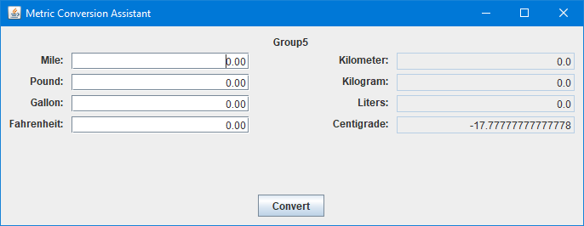

* Constant Declaration

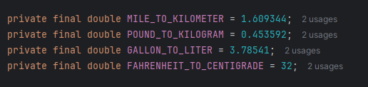

* Conversion Value

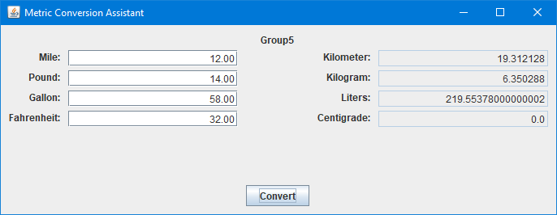

* Exception Handler

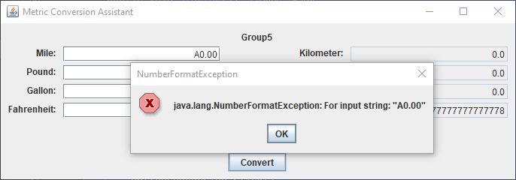

Tack B:

* Startup

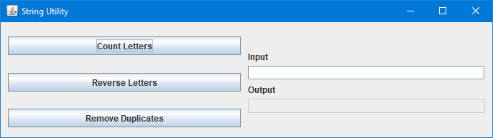

* Count Letters

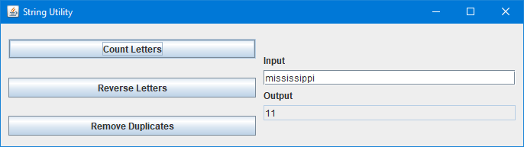

* Reverse Letters

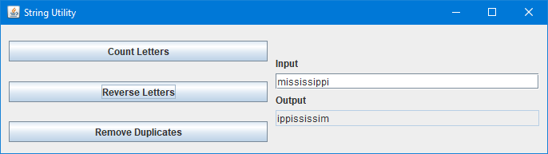

* Remove Duplicates

